*2013 Biological Sciences Year 9*

End Topic Test

Name: ________________ Class:____ Date:________

Score: ___________ / 70 marks

Section A—Multiple choice (14 marks)

|  |  |  |  |  |
| --- | --- | --- | --- | --- |
| Question |  |  |  |  |
| 1 | A | B | C | D |
| 2 | A | B | C | D |
| 3 | A | B | C | D |
| 4 | A | B | C | D |
| 5 | A | B | C | D |
| 6 | A | B | C | D |
| 7 | A | B | C | D |
| 8 | A | B | C | D |
| 9 | A | B | C | D |
| 10 | A | B | C | D |
| 11 | A | B | C | D |
| 12 | A | B | C | D |
| 13 | A | B | C | D |
| 14 | A | B | C | D |

1. Another name for bacteria

1. Microorganisms
2. Pathogens
3. Virus
4. Protozoans

2 Explain why some food is stored in the refrigerator

1. The cold temperature kills bacteria
2. The growth of bacteria slows down
3. It is a convenient storage space for similar types of food
4. Viruses cannot survive under these conditions

3. What is the name of anything that causes disease

1. Antibody
2. Bacterium
3. Pathogen
4. Host

4. What are lymphocytes

1. Balls of pus containing dead microorganisms
2. Disease fighting white blood cells
3. Collections of bacterial cells within the body
4. Harmful pathogens that shed of the skin

5. Describe an antibody

1. A type of white blood cell that destroys pathogens
2. A foreign substance that causes disease in the human body
3. A drug produced to treat bacterial infections
4. A chemical produced by the body in response to the presence of pathogens

6. When your body is invaded by ______ your _______ respond by making ________. These disable the invader. Identify the 3 missing words in correct order.

1. Antibodies, lymphocytes, pathogens
2. Pathogens, lymphocytes , antibodies
3. Pathogens, antibodies, lymphocytes
4. Lymphocytes, pathogens, antibodies

7. Bacteria that are human pathogens grow and reproduce very rapidly only when the conditions are right. Describe these conditions

1. Cold and dry
2. Warm and moist
3. Cold and moist
4. Warm and dry

8. Describe a contagious human disease

1. An infectious disease that is very easily transmitted from person to person
2. A disease that is caused by a chemical in the environment
3. A disease that affects large numbers of people in a particular population
4. A disease that is passed from parents to children

9. Describe an antigen

1. A foreign substance that causes disease in the human body
2. A type of white blood cell that can destroy some pathogens
3. A drug produced to treat bacterial infections
4. A chemical produced by the body in response to the presence of pathogens

10. What could be the most difficult problem faced in the fight against disease

1. The large number of bacteria and viruses that exist making fighting the disease difficult
2. Viruses change quickly forming new varieties
3. Viruses are too small to be identified using light microscopes
4. Some people are allergic to the drugs used to fight bacterial infections

11. Identify the reaction that does not occur as part of the body’s second line of defence against disease

1. Neutrophils move to the damaged area and begin to consume bacteria
2. Blood flow to the damaged area is increased
3. Lymphocytes move to the damaged area and begin to make antibodies
4. The damaged area becomes red and swollen

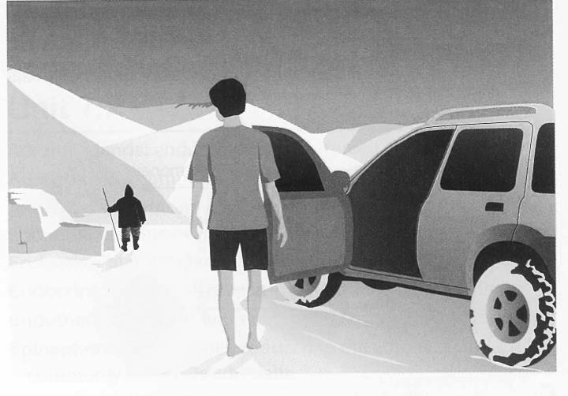12. Identify the change that is **UNLIKELY** to be occurring in the body of the young man

1. Reduced heart rate
2. Shivering
3. Increased levels of Cell Respiration
4. Constriction of blood vessels to the

…………..skin, fingers and toes

13. Two groups of people were involved in trial to see which activity had the greatest effect on total urine production. One group sat in the full sun on a hot day for 30 minutes. The other group exercised vigorously for 30 minutes. Neither group had anything to drink after the experiment started

Average urine production was measured at ½ hourly intervals –results below

|  |  |  |
| --- | --- | --- |
| **Time** | **Volume of Urine produced (mL)** | |
|  | Group 1 | Group 2 |
| 0 | 50 | 50 |
| 30 | 53 | 50 |
|  | **Vigorous Exercise for 30 Minutes** | **Sat in the sun for 30 Minutes** |
| 60 | 60 | 30 |
| 90 | 10 | 20 |
| 120 | 8 | 20 |
| 150 | 35 | 25 |
| 180 | 40 | 23 |

Which is **MOST LIKELY** to be true:

1. In the time following the activity ( exercise or sunbaking) the group who were sunbaking produced less urine.
2. In the time following the activity ( exercise or sunbaking) the group who were exercising produced less urine
3. Both groups produced the same amount of urine in total
4. There was a steady decline in the amount of urine produced by both groups

14. The following graphs show the activity level of a human ENZYME at different temperatures and pH

Normal internal temperature of the human body is 37OC. pH Levels of body sections are as follows: mouth is pH7.5, the stomach is pH 3 and small intestines is pH 8

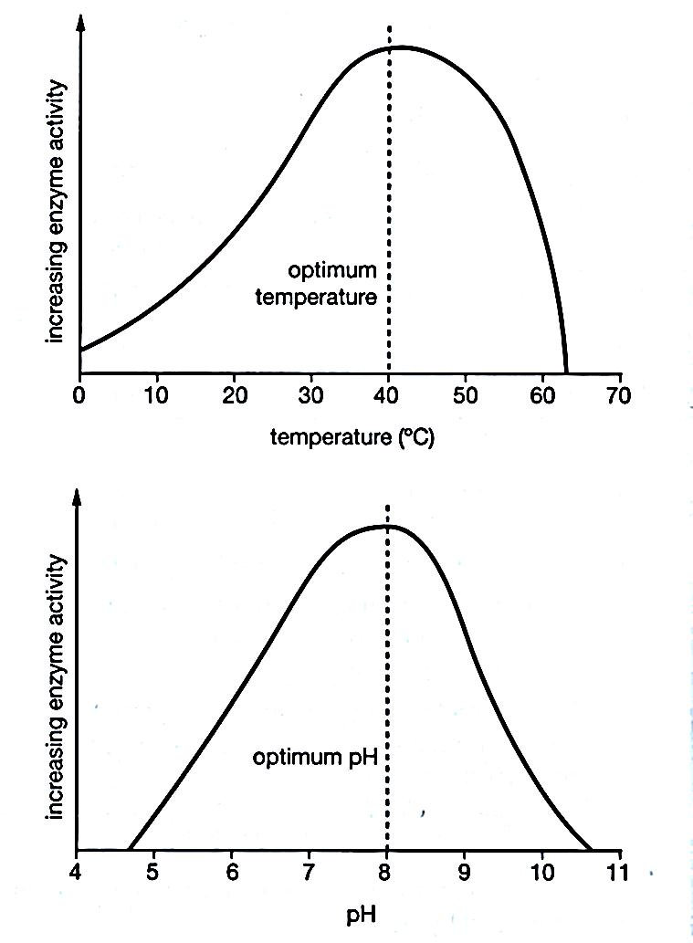

Select the **CORRECT** statement

a) The enzyme would be able to function best in the small intestine

b) The enzyme works best at low pH and high temperature

c) Temperature and pH have no effect on the activity of the enzyme

d) The enzyme is most likely a digestive enzyme from the stomach

**Short Answer Section --- Answer in spaces provided**

1. Define the word disease (2 marks)

______________________________________________________________________________________________________________________________________________________________________________________________________________________________________________________

__________________________________________________________________________________

2. Explain the difference between an infectious disease and a contagious disease (2 marks)

____________________________________________________________________________________________________________________________________________________________________

____________________________________________________________________________________________________________________________________________________________________

3. List the main differences between Bacteria and a Virus (6 marks)

|  |  |
| --- | --- |
| Bacteria | Virus |
|  |  |
|  |  |
|  |  |

4. Circle **the 4 CORRECT** ways that a pathogen can enter your body? (4 marks)

Food and water

Running too fast

Smelling a clean area

Sleeping

Breathing in

Cuts and wounds

Sexual contact

Looking at a picture of a disease

5. Match the **CORRECT LETTER** of the descriptions of the body’s defence mechanisms to protect the body from pathogens (11 marks)

|  |  |  |  |
| --- | --- | --- | --- |
| A | Coughing |  | Removal of pathogens in stomach which have been ingested |
| B | Saliva |  | Protects internal organs from sunlight and harmful carcinogens in the environment |
| C | Neutrophils |  | In stomach kills bacteria before they reach the intestines |
| D | Acid |  | Contains substances to help resist and remove pathogens |
| E | Mucus |  | in the lining of the nose and throat traps foreign particles |
| F | Lymphatic system |  | Cells in the bloodstream destroy pathogens |
| G | Skin |  | Lymph nodes and lymphocytes &macrophages engulf and destroy pathogens |
| H | Vomiting |  | Have a mild antiseptic property and help wash away dirt and harmful substances |
| I | Tears |  | Removal of pathogens that have been partially digested |
| J | Nose |  | Hair in nasal cavity can trap dirt and dust |
| K | Diarrhoea |  | Removal of foreign particles from the trachea |

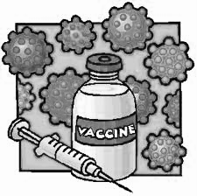6. Explain how vaccines work (2 marks)

____________________________________________________________________________________________________________________________________________________________________________________________________________________________________________________________________________________________________________________________________

7. Complete the table about common diseases caused by Virus. Describe symptoms and recommended treatment

|  |  |  |
| --- | --- | --- |
| Common Disease | Symptoms | Treatment |
|  | coughing, sneezing, runny nose, sore throat | Rest, fluids and pain relief |
| Measles |  | Immunisation |
|  | runny nose, slight fever, small very itchy blisters |  |

(4 marks)

8. Describe the relationship between a parasite and its host (2 marks)

A parasite_________________________________________________________________________

__________________________________________________________________________________

A host ___________________________________________________________________________

__________________________________________________________________________________

9. **Add the labels** to the diagram to explain a stimulus –response reaction the body has to being too HOT (5 marks)

Take off jumper

Heat is stimulus

Sensory nerve relays signal

Hypothalamus

Motor nerve

Motor nerve

Muscles of the arm (effector)

Sweat glands (effector)

Begin to sweat to cool body

Temperature receptors in skin

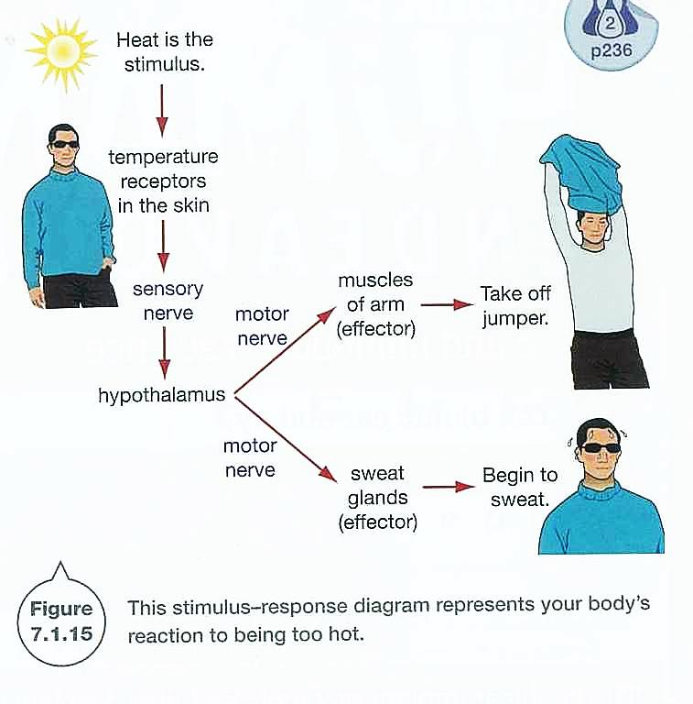

10. Explain how diseases can be prevented by practising good hygiene (4 marks)

* ____________________________________________________________
* ____________________________________________________________
* ____________________________________________________________
* ____________________________________________________________

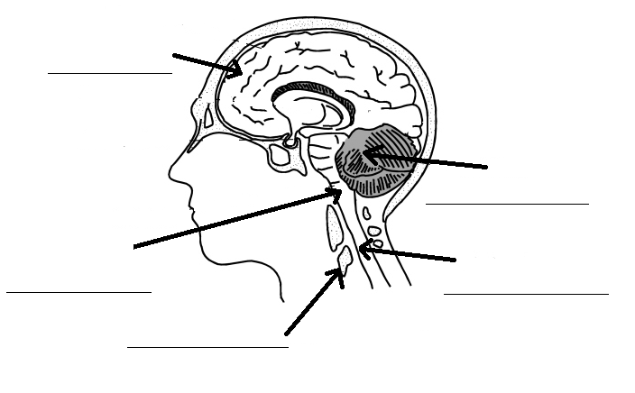11. Label the diagram of THE BRAIN (5 marks)

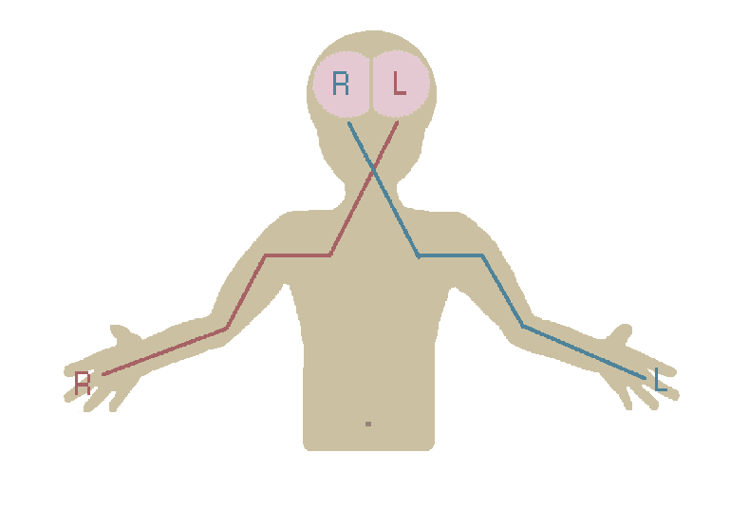12. Look at the diagram on the right. (3 marks)

1. What side of the body does the right hemisphere control? ____________________________
2. What side of the body does the left hemisphere control? ____________________________
3. Each half of the brain can work independently: TRUE/FALSE

13. Draw a **NEURON** in the space below

Label each of these in your diagram (6 marks)

AXON MYELIN SHEATH CELL BODY

DENDRITES AXON TERMINAL

End of Test --- check your answers